ANNEXURE I

**A PROJECT REPORT ON**

**“e – VOTING APPLICATION”**

***Submitted to***



**DIBRUGARH UNIVERSITY**

**By**

* **SAIFUL ISLAM (17992043)**
* **SUMIT GHOSH (17992047)**
* **AZIZ BARMAN (17992019)**

**In partial fulfillment for minor project of fourth semester**

**BACHELOR OF COMPUTER APPLICATION**

**CENTRE FOR COMPUTER SCIENCE AND APPLICATION**

**DIBRUGARH UNIVERSITY,**

**DIBRUGARH – 786004,**

**ASSAM, INDIA.**

**BATCH (2017- 2020)**

ANNEXURE II

**CERTIFICATE**

**This is to certify that the project report entitled “e- VOTING APPLICATION” submitted by SAIFUL ISLAM (17992043), SUMIT GHOSH (17992047) and AZIZ BARMAN (17992019) to DIBRUGARH UNIVERSITY, DIBRUGARH, ASSAM, in partial fulfillment for minor project of fourth semester Bachelor of Computer Applications. It is a bonafide record of the project work carried out by them under my supervision during the year 2017-2020.**

**Guide:**

**Name:**

**Signature:**

**Date:**

ANNEXURE III

**CERTIFICATE**

**This is to certify that the project report entitled “e- VOTING APPLICATION” submitted by SAIFUL ISLAM (17992043), SUMIT GHOSH (17992047) and AZIZ BARMAN (17992019) to DIBRUGARH UNIVERSITY, DIBRUGARH, ASSAM, in partial fulfillment for minor project of fourth semester Bachelor of Computer Applications. It is a bonafide record of the project work carried out by them during the year 2017-2020.**

**Chairperson,**

**CCS, DU**

ANNEXURE IV

**EXAMINATION CERTIFICATE**

**This is to certify that the project report entitled “e- VOTING APPLICATION” submitted by SAIFUL ISLAM (17992043), SUMIT GHOSH (17992047) and AZIZ BARMAN (17992019) of Centre for Computer Science and Application, Dibrugarh University has carried out the Project Work in a manner satisfactory to warrant its acceptance and also defended it successfully. I wish him them all the success in their future endeavour.**

**Examiners:**

1. **External Examiner:**

**02. Internal Examiner:**

ANNEXURE V

**DECLARATION**

**I hereby declare that the Dissertation work entitled “e- VOTING APPLICATION” submitted to the Dibrugarh University, Dibrugarh, Assam, in partial fulfillment for minor project of fourth semester Bachelor of Computer Applications. It is an original work done by us under the guidance of KAUSTUVMONI BORDOLOI and has not been submitted for the award of any degree.**

**Signature of the student’s**

**Name: Name: Name:**

**Roll No.: Roll No.: Roll No.:**

**CCSA, DU CCSA, DU CCSA, DU**

ANNEXURE VI

**ACKNOWLEDGEMENT­**

The Present project work is a humble and maiden effort of the work concerned with the “e-Voting Application” and has been a large success for the generous help and guidance received by us from several persons and quarters.

We also extend deep gratitude to my project guide for his guidance and his encouragement for us; it was unfailing source of reward experience.

We also express our gratitude to, for providing generous advice and moral support.

We are also t­­­hankful to all teachers for their help and timely advice

Finally thanks to all our friends in the department for their kind co-operation and help inside as well as outside the college.

SAIFUL ISLAM

SUMIT GHOSH

AZIZ BARMAN

BCA 4TH SEMESTER

CCSA, DIBRUGARH UNIVERSITY

**Page Index**

**ABSTRACT……………………………………………………………………………………….1**

**1. INTRODUCTION……………………………………..…………………………………….2-3**

**2. FEASIBILITY STUDY……………………………………………………………………....4-8**

**3. DESIGN………………………………………………………………………………………..9-12**

**4. SYSTEM DESIGN...……………………………………………………………………… 13-25**

**ABBREVIATIONS……………………………………………………………………………….26**

**CONCLUSION………………………………………………………………………………....27**

**REFERENCES…..………………………………………………………………………………..28**

**Table Index**

**1. LIST OF TABLES…………………………………………………………………17-18**

**1.1 ADMIN INFORMATION TABLE…………………………………………17**

**1.2 CANDIDATE INFORMATION DATA TABLE………………………..17**

**1.3 VOTER INFORMATION DATA TABLE…………………………………18**

**Figure Index**

**DATA FLOW DIAGRAMS………………………………………………………….13**

**DFD: LEVEL 0……………………………………………………………………….13**

**DFD: LEVEL 1……………………………………………………………………….14-15**

**ER DIAGRAMS…………………………………………………………………………16**

**UI-UX …………………………………………………………………………………….20-26**

**ABSTRACT**

**Resources Required:-**

Development Tool - JavaFx

Database - My Sql

Server - XAAMP Server

**INTRODUCTION**

“E–VOTING APPLICATION” is an online voting technique. In this system students who are enrolled in the department of any gender can give his/her vote online without going to any polling booth. There is a DATABASE which is maintained by the admin of the department in which all the names of voter with complete information is stored.

**SCOPE**

* This system will increase the voting percentage in the Department.
* If high security is applied then it may reduce false vote.

**WORKING**

In “e - VOTING APPLICATION” a voter can use his\her voting right online without any difficulty. Admin can add voters and candidate of the department. All the entries are checked by the DATABASE which has already all information about the voter. If all the entries are correct then a USER ID and PASSWORD is given to the voter, by using that ID and PASSWORD he\she can use his\her vote. If conditions are wrong then that entry will be discarded

Page 1 of 31

**INTRODUCTION**

**1.1 OBJECTIVE**

The main objectives of system for *E-voting Application* are:

* The objective of E-voting Application is to help the organization in automating the whole manual processing of the existing system.
* The main objective to develop the system is to make the accurate & efficient decisions in different tasks at different time at different situations. The existing system is manual so members of the unit generally face a lot of embarrassing situations many times. Now they need to automate the whole process so as to make it more easy and accurate.
* System should support multi-user environment.
* System should be fully automated.
* System should provide concrete security features like creating users and assigning privileges to users of the system.
* System should be capable to keep track of all the detailed descriptions of the client and the whole details of services offered by the client organization.
* Various outputs (reports) should be available online any time.
* System should be able to handle extremely large volumes of data (i.e. Large database support)

Page 2 of 31

**1.2 ABOUT THE PROJECT**

* Project is related to E-Voting Application.
* The project maintains three levels of users:-
  + - Administrator Level
    - Voter Level
    - Candidate Level
* Main facilities available in this project are:-
  + - Maintaining voter’s Identification.
    - Providing E-voting management.
    - Providing Updation of voter’s information.
    - Providing Updation of Candidate’s information.
    - Provide voter information to ADMIN OF THE SYSTEM
  + ADMIN maintains the complete information of voter and candidate.
  + Voter can give his\her vote for any candidate in the department.

Page 3 of 31

**FEASIBILITY STUDY**

Depending on the results of the initial investigation the survey is now expanded to a more detailed feasibility study. “*FEASIBILITY STUDY*” is a test of system proposal according to its workability, impact of the organization, ability to meet needs and effective use of the resources. It focuses on these major questions:

1. What are the user’s demonstrable needs and how does a candidate system meet them?

2. What resources are available for given candidate system?

3. What are the likely impacts of the candidate system on the organization?

4. Whether it is worth to solve the problem?

During feasibility analysis for this project, following primary areas of interest are to be considered. Investigation and generating ideas about a new system does this.

Steps in feasibility analysis

Eight steps involved in the feasibility analysis are:

* Form a project team and appoint a project leader.
* Prepare system flowcharts.
* Enumerate potential proposed system.
* Define and identify characteristics of proposed system.
* Determine and evaluate performance and cost effective of each proposed system.
* Weight system performance and cost data.
* Select the best-proposed system.

Page 4 of 31

**2.1 Technical feasibility**

A study of resource availability that may affect the ability to achieve an acceptable system. This evaluation determines whether the technology needed for the proposed system is available or not.

* Can the work for the project be done with current equipment existing software technology & available personal?
* Can the system be upgraded if developed?
* If new technology is needed then what can be developed?
* This is concerned with specifying equipment and software that will successfully satisfy the user requirement. The technical needs of the system may include:

Front-end and back-end selection

An important issue for the development of a project is the selection of suitable front-end and back-end. When we decided to develop the project we went through an extensive study to determine the most suitable platform that suits the needs of the organization as well as helps in development of the project.

The aspects of our study included the following factors.

Front-end selection:

1. It must have a GUI that assists employees that are not from IT background.

2. Scalability and extensibility.

3. Flexibility.

4. Robustness.

5. According to the organization requirement and the culture.

Page 5 of 31

6. Must provide excellent reporting features with good printing support.

7. Platform independent.

8. Easy to debug and maintain.

9. Event driven programming facility.

10. Front end must support some popular back end like Ms Access.

According to the above stated features we selected Javafx as the front-end for

developing our project.

Back-end Selection:

1. Multiple user support.

2. Efficient data handling.

3. Provide inherent features for security.

4. Efficient data retrieval and maintenance.

5. Stored procedures.

6. Popularity.

7. Operating System compatible.

8. Easy to install.

9. Various drivers must be available.

10. Easy to implant with the Front-end.

According to above stated features we selected MY SQL as the backend and PhpMyAdmin for database management.

The technical feasibility is frequently the most difficult area encountered at this stage. It is essential that the process of analysis and definition be conducted in parallel with an assessment to technical feasibility. It centres on the existing computer system and to what extent it can support the proposed system.

Page 6 of 31

**2.2 Economical feasibility**

Economic justification is generally the “Bottom Line” consideration for most systems. Economic justification includes a broad range of concerns that includes cost benefit analysis. In this we weight the cost and the benefits associated with the candidate system and if it suits the basic purpose of the organization i.e. profit making, the project is making to the analysis and design phase.

The financial and the economic questions during the preliminary investigation are verified to estimate the following:

* The cost to conduct a full system investigation.
* The cost of hardware and software for the class of application being considered.
* The benefits in the form of reduced cost.
* The proposed system will give the minute information, as a result the

Performance is improved

* This feasibility checks whether the system can be developed with the available funds. The Online voting system does not require enormous amount of money to be developed. This can be done economically if planned judicially, so it is economically feasible. The cost of project depends upon the number of man-hours required.

Page 7 of 31

**2.3 Operational Feasibility**

It is mainly related to human organizations and political aspects. The points to be considered are:

* What changes will be brought with the system?
* What organization structures are disturbed?
* What new skills will be required? Do the existing staff members have these skills? If not, can they be trained in due course of time?

The system is operationally feasible as it very easy for the End users to operate it. It only needs basic information about Windows platform.

**2.4 Schedule feasibility**

Time evaluation is the most important consideration in the development of project. The time schedule required for the developed of this project is very important since more development time effect machine time, cost and cause delay in the development of other systems.

A reliable Online voting system can be developed in the considerable amount of time

Page 8 of 31

**DESIGN**

**3.1 Software Requirement Specification**

**3.1.1 Objective**

The main objectives of system for *e - Voting Application* are:

* The objective of *e - Voting Application* is to help the department in automating the whole manual processing of the existing system.
* The main objective to develop the application is to make the accurate & efficient decisions in different tasks at different time at different situations. The existing system is manual so members of the unit generally face a lot of embarrassing situations many times. Now they need to automate the whole process so as to make it more easy and accurate.
* System should support multi-user environment.
* System should be fully automated.
* System should provide concrete security features like creating users and assigning privileges to users of the system.
* System should be able to handle extremely large volumes of data (i.e. Large database support)

Page 9 of 31

**3.1.2 Scope**

1. Advanced technology: It is an advanced technology used now days. It increases the e knowledge of the users which is very necessary for current generation.
2. Internet: It is an online facility and hence very useful for the users.

Voters have to vote from the department where the application is installed.

**3.1.3 Advantages:**

* Fast and easy service.
* The *e - Voting Application* provides a less time consuming.
* It reduces the paper work and makes the work less tedious for faculty members of department.
* It is a better way for voting.
* By this voting percentage will increase drastically.

**3.1.4 Technologies to be used:**

This project will be a desktop application to be developed in JavaFx environment having

* Database Design (My SQL)
* Form Design (JavaFx)
* Coding (JAVA)
* Testing (XAAMP SERVER)

Page 10 of 31

* + 1. **OVERVIEW:**

**1. Requirements**

**•** FUNCTIONAL REQUIREMENTS:

* Registration of the voter is done admin of the department.
* Admin of the department can change the information any time if required.
* Voter is given a unique ID and PASSWORD.

Voter can give vote after login and entering the ID and PASSWORD.

* In the DATABASE information of every voter and candidate is stored.
* Database shows the information of every user.

• NON-FUNCTIONAL REQUIREMENTS:

1. Secure access of confidential data (user’s details). SSL can be used.
2. 24 X 7 availability.
3. Better component design to get better performance at peak time.
4. Flexible service based architecture will be highly desirable for future extension

Page 11 of 31

**2. Project Requirements**

Hardware Requirements (Processor *RAM Disk Space)*

Pentium II, Pentium III, Pentium IV, Higher 64 Mb or Higher 130 Mb Software Requirements (Operating *System Database)*

Win-98, Win-XP, Linux, My SQL

**3. Software interface:**

• Web Server: XAAMP Server, Operating System (Windows)

• Data Base server: MYSQL, Operating System (Windows).

Page 12 of 31

**SYSTEM DESIGN**

**4.1 DFD:-**

* **LEVEL 0**

**username &password Response**

**ADMIN**

**VOTER**

**Response username &password**

**Fig: - DFD Level-0**

**DFD Level 0**

The above diagram is a 0-level DFD that only shows the flow of data between the various entity and the system. In E-voting Application

the Administrator is the controller of the system and all the decisions are made by him. The Administrator can handle the entire voter and their details, voting details etc. and view details of them and he/she can update that details**.**

Page 13 of 31

* **LEVEL 1**

**ADMIN**

**USERNAME & RESPONSE**

**PASSWORD**

**VOTER ‘S ENTRY CANDIDATE’S ENTRY**

**Generate Result**

**VOTER’S CANDIDATE’S**

**DETAILS DETAILS**

**UPDATE USE DATABASE**

**DATABASE**

VOTER DB CANDIDATE DB

**Fig: - DFD Level-1(ADMIN)**

**DFD Level 1**

The above shown diagram is a 1-level Data Flow Diagram for the E-voting system. According to this DFD various process are done after login process. The ADMIN can register the voters and voter can use their voting rights. The ADMIN can view the final report after voting is ended and auto-generated mail will be sent to the respective voters.

Page 14 of 31

* **LEVEL 1**

**VOTER**

**USERNAME & RESPONSE**

**PASSWORD**

Check details

Reply voter

**VOTES**

**UPDATE**

**VOTER DB**

**Fig:- DFD Level-1(VOTER)**

Page 15 of 31

**4.2 ERD:**

**ADMIN**

**VOTER**

**Votes**

**CANDIDATE**

**1 1**

**Manages**

**Manages**

**M M**

**M 1**

Achievement

Ph_number

Fig: - ER-diagram

Page 16 of 31

**ER-DIAGRAM:-**

The above entity relationship diagram shows the relationship between the various users and their attributes. There is a relationship between the admin, voter and candidate.

Page 6 of 31

**4.3 LIST OF TABLES**

**Admin Table:-**

|  |  |  |  |
| --- | --- | --- | --- |
| **S. No.** | **Field Name** | **Data Type** | **Description** |
|  | **Admin_id** | **Varchar** | **Login id for Admin.(Primary key)** |
|  | **Password** | **Varchar** | **Password for Login** |
|  | **V_Year** | **Number** | **Voting year** |

**Candidate information Data Table:-**

|  |  |  |  |
| --- | --- | --- | --- |
| **S. No** | **Field Name** | **Data Type** | **Description** |
| **1.** | **C_id** | **Varchar** | **Login id for candidate (primary key)** |
| **2.** | **C_name** | **Varchar** | **Name of the candidate** |
| **3.** | **C_pos** | **Varchar** | **Name of the candidate position** |
| **4.** | **Achievement** | **Varchar** | **Achievements in different fields by the candidate** |

Page 6 of 31

**Voter information Data Table:-**

|  |  |  |  |
| --- | --- | --- | --- |
| **S. No.** | **Field Name** | **Data Type** | **Description** |
|  | **V_ id** | **Varchar** | **Login id for Voter (Primary key)** |
|  | **V_pass** | **Varchar** | **Password for Login** |
|  | **V_name** | **Varchar** | **Name of the voter** |
|  | **Session** | **Number** | **Course year of the voter** |
|  | **Ph_number** | **Number** | **Phone No of the voter** |
|  | **Voted** | **Number** | **Voted yes or no** |

Page 6 of 31

**Database :**

**1.Voter**

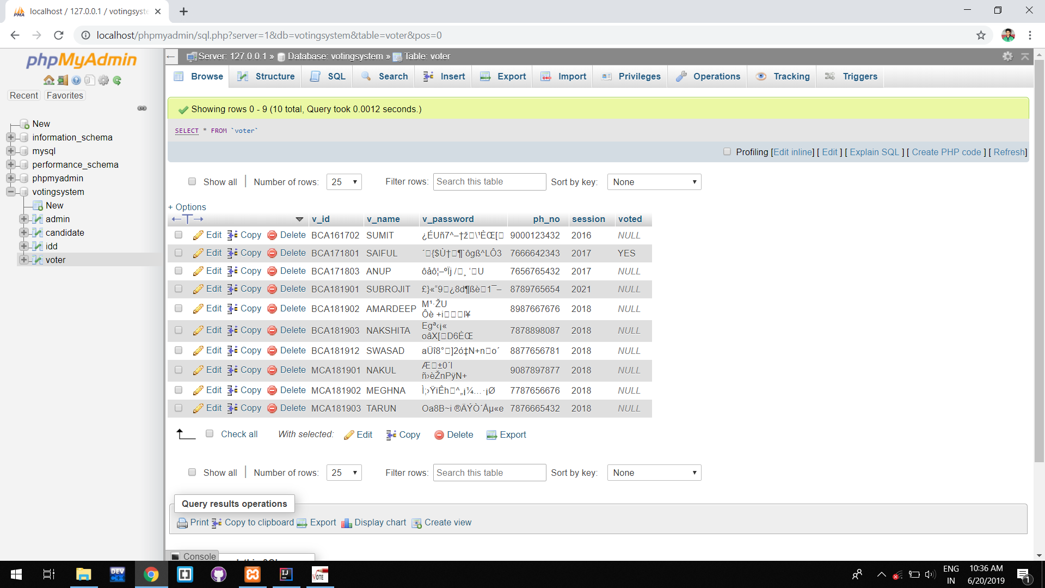

Page 6 of 31

**2. Candidate**

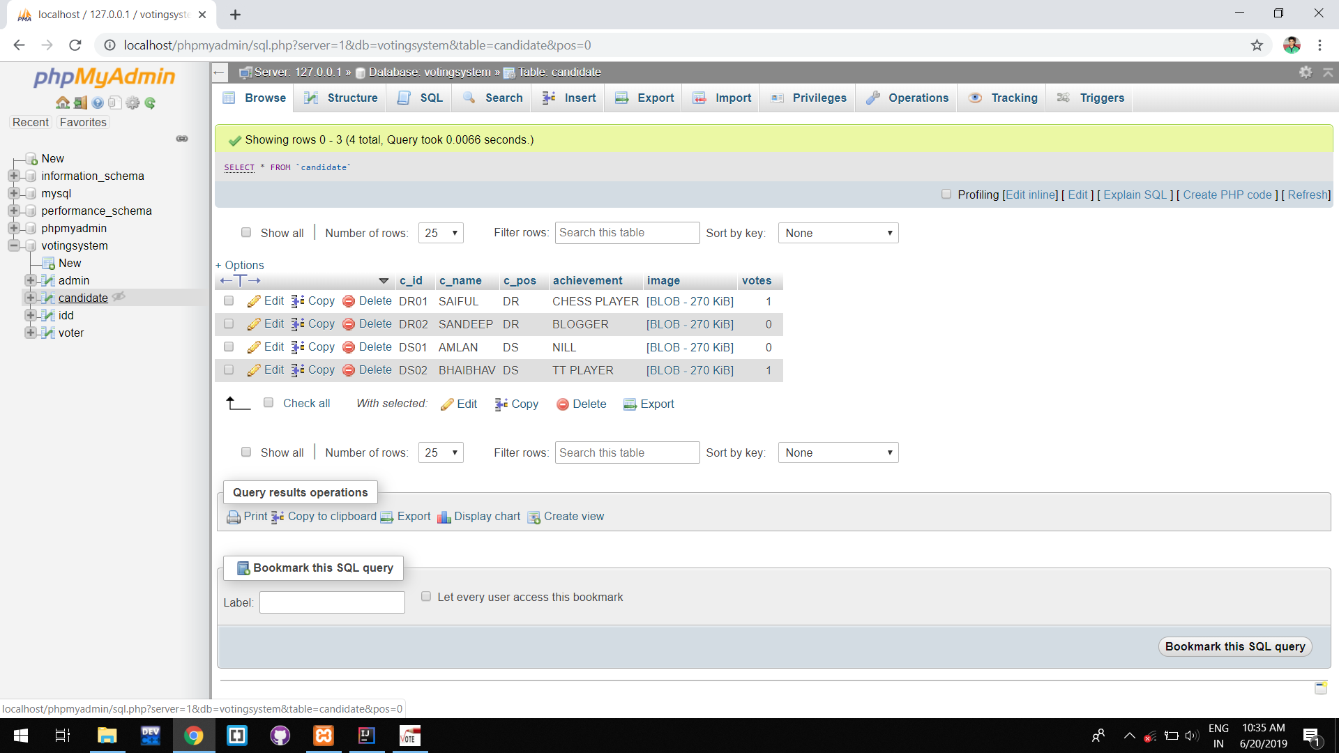

Page 6 of 31

* 1. **UI-UX**

**1. LOGIN PAGE:**

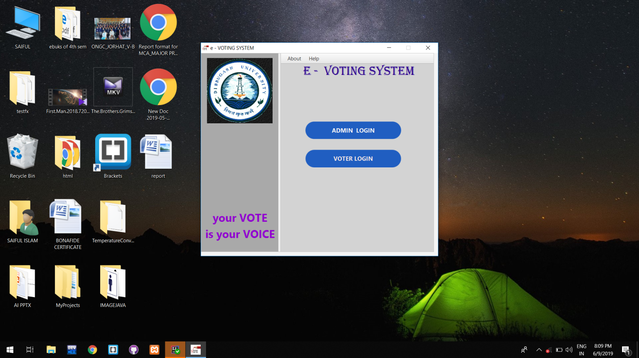

Page 6 of 31

**2. ADMIN LOGIN:**

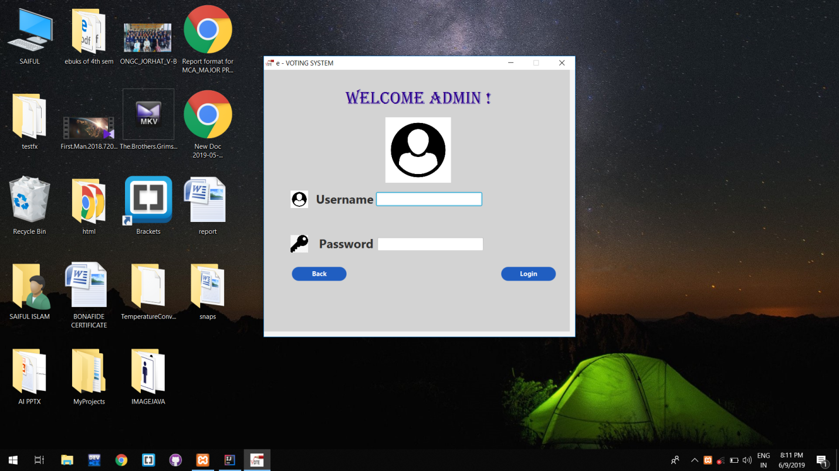

Page 6 of 31

**3. DASHBOARD:**

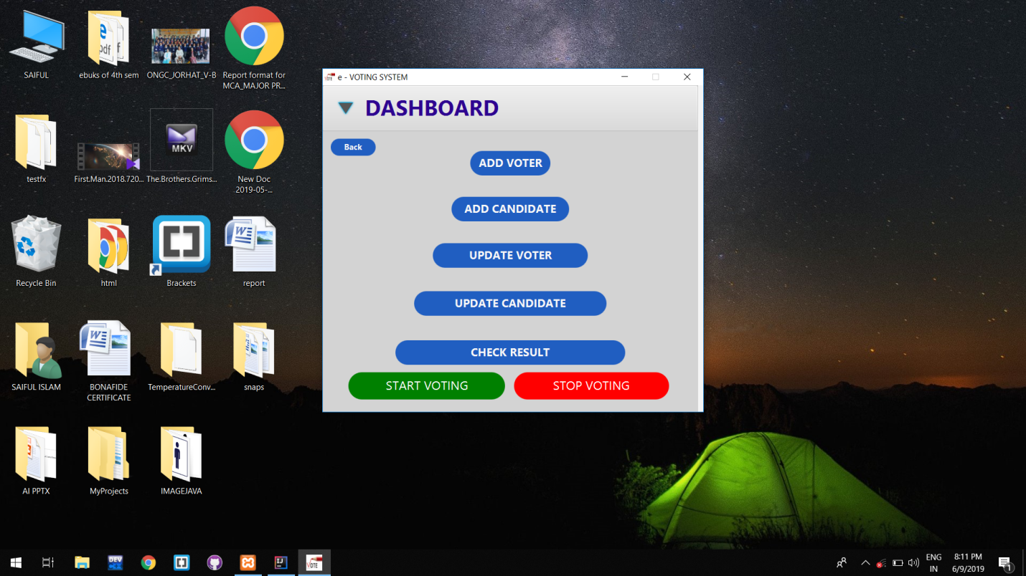

Page 6 of 31

**4. ADD VOTER:**

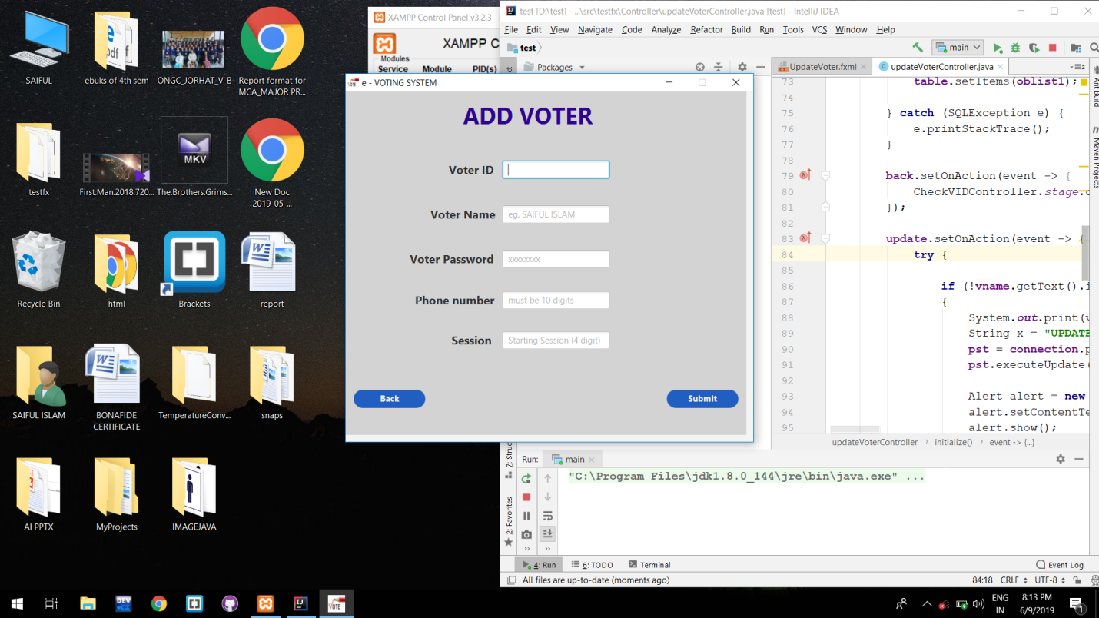

Page 6 of 31

**5. UPDATE VOTER:**

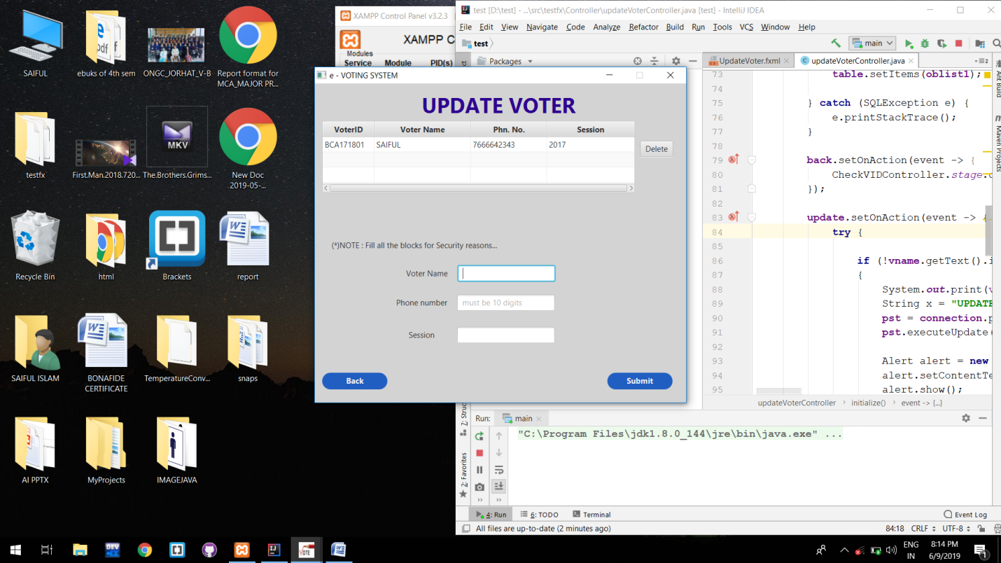

Page 6 of 31

**6. VOTING PAGE:**

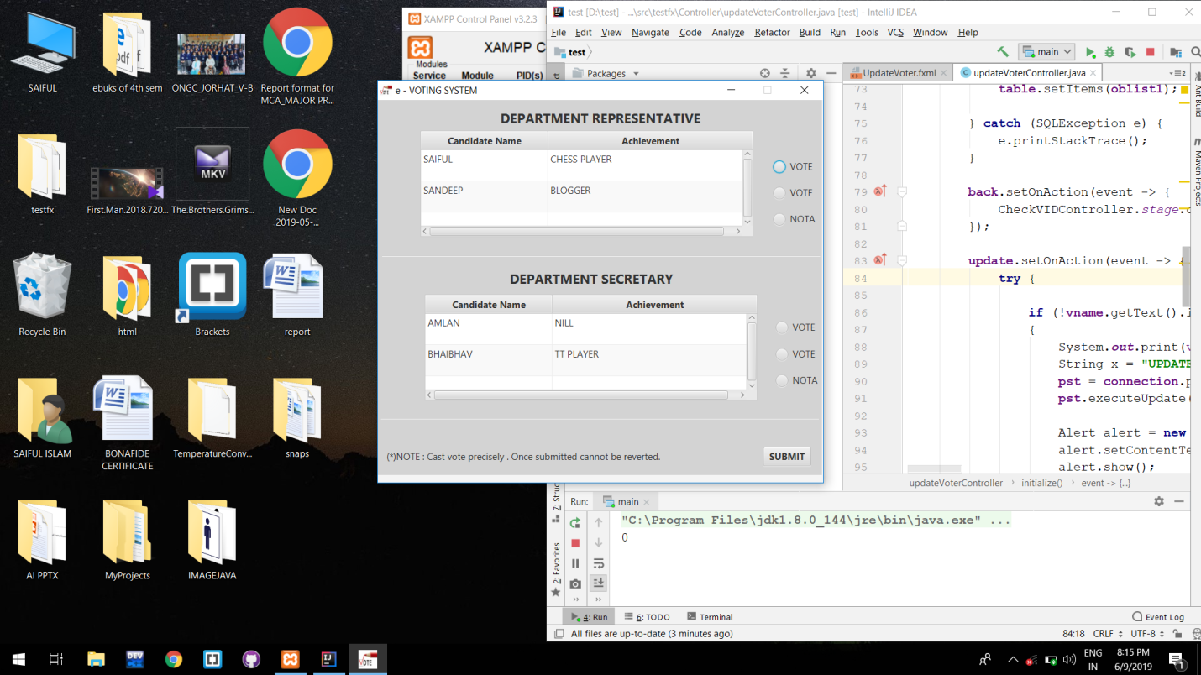

Page 6 of 31

**7. RESULT PAGE:**

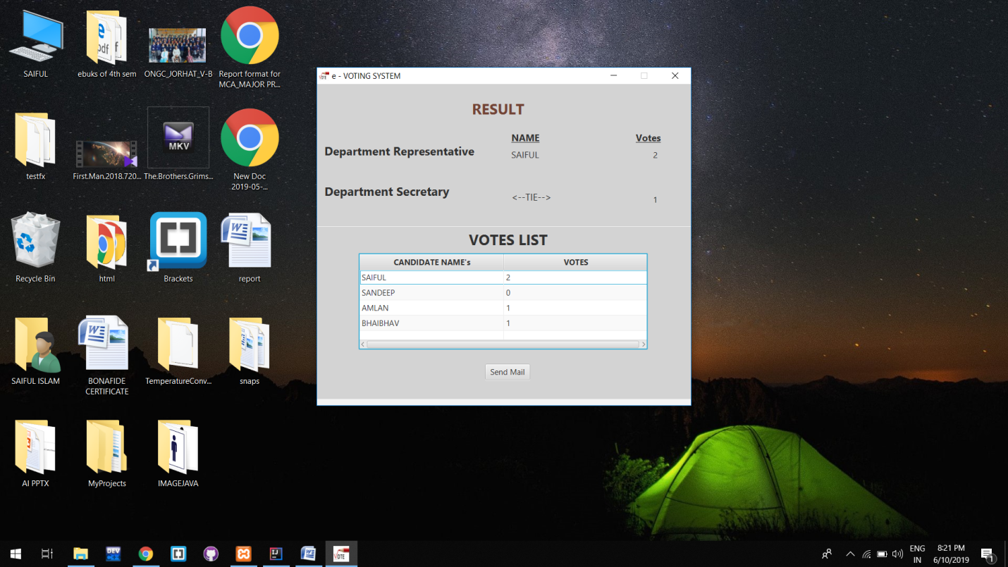 Page 6 of 31

**ABBREVIATIONS**

**URL UNIFIED RESOURCE LOCATOR**

**HTML HYPERTEXT MARK-UP LANGUAGE**

**DFD DATA FLOW DIAGRAM**

**ERD ENTITY RELATIONSHIP DIAGRAM**

**WBS WORK BREAKDOWN STRUCTURE**

Page 6 of 31

**CONCLUSION**

This E-Voting application will manage the Voter’s information by which voter can login and use his voting rights. The system will incorporate all features of voting system. Its provide the tools for maintaining voter’s vote to every candidate and it count total no. of votes of every candidate. There is a DATABASE which is maintained by the ADMIN OF THE DEPT. in which all the names of voter with complete information is stored.

In this user who belongs to the DEPT. can register his/her information on the database through ADMIN and when he/she want to vote he/she has to login by his id and password and can vote to a candidate only one time. Voting details store in database and the result is displayed by calculation. By e-voting application percentage of voting is increases. It decreases the cost and time of voting process. It is very easy to use and it is very less time consuming. Also it is very easy to debug.

Page 6 of 31

**REFERENCES**

* [**https://www.internshala.com/**](https://www.internshala.com/)
* [**https://stackoverflow.com/**](https://stackoverflow.com/)
* [**https://www.quora.com/**](https://www.quora.com/)
* [**https://www.geeksforgeeks.com/**](https://www.geeksforgeeks.com/)
* [**https://www.w3schools.com/**](https://www.w3schools.com/)

Page 6 of 31